10:00 am-6:00pm
December 21-22, 2019
Bradley Square Mall Cleveland TN

Black Friday & Saturday
November 29-30, 2019
Bradley Square Mall Cleveland TN
10:00 am-6:00pm
December 15-16, 2019
Bradley Square Mall Cleveland TN

Nov. 29-30th-Bradley Square Mall-Cleveland, TN
Dec 14-15th-Bradley Square Mall, Cleveland, TN
Dec 21-22nd -Bradley Square Mall, Cleveland, TN
www. homefortheholidaysEXPO.net
Organizers: Tina Wilkins-706-913-6892 or 423-486-7597-twilkins@targetmarketingmedia.com Harold Wilkins-706-313-4409 Presented by:

Home for the Holidays EXPO
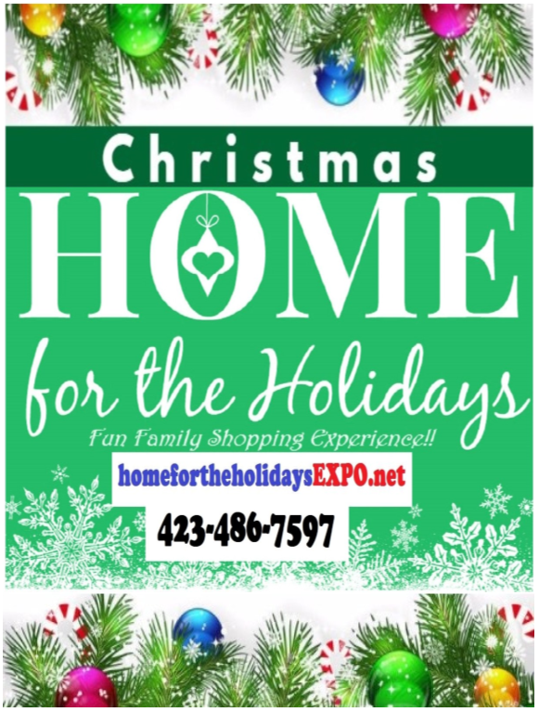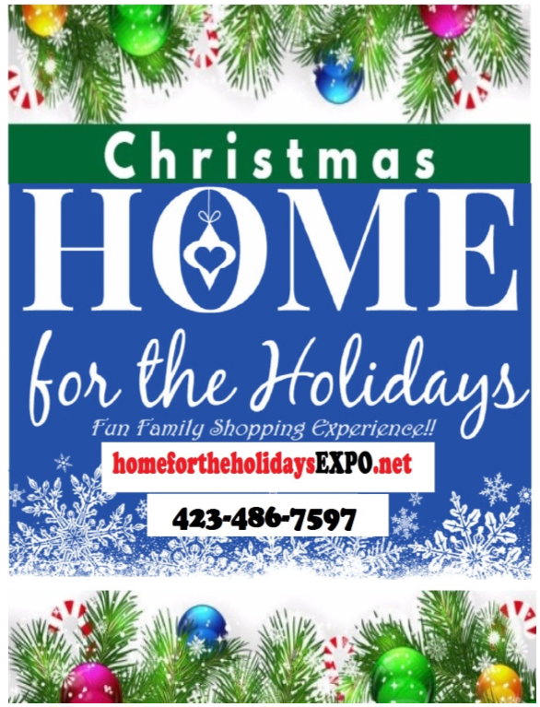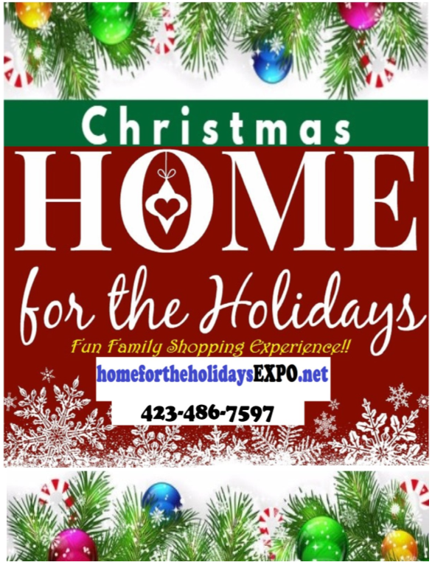

Vendors Packet (Rules, Tips Etiquette) facebook.com/targetmarketingmedia

Home For The Holidays EXPO Rules
LOCATION OF EVENTS
Nov. 29-30: Bradley Square Mall – 200 Paul Huff Pkwy NW. Cleveland, TN
Dec. 14-15: Bradley Square Mall 200 Paul Huff Pkwy Cleveland, TN
Dec. 21-22: Bradley Square Mall 200 Paul Huff Pkwy Cleveland, TN

Please distribute a copy of these rules to anyone who will be assisting in your setup/breakdown for the Home For the Holidays EXPO. The Location(s) will be open to the Vendors on the following dates. (Friday/Saturday), November 29-30, (Set up 8am-10am) 10am-6pm or longer?? December 14, 15, 21 & 22 from 7:30am – 10:00am (setup/breakdown). .

**ALL VENDORS MUST ABIDE BY THESE RULES ARE SUBJECT TO CHANGE** THINGS TO REMEMBER
- Vendors are responsible for any Tennessee Sales Tax and any required local vending licenses.
- Vendors may sell only items noted on their vendor application.
- Vendors must bring a door prize drawing valued at least $15-$30 gift, gift certificate etc., “
- Please visit our website www.targetmarketingmedia.com for all the upcoming Festivals and Expo to sign up for.
- NO ANIMALS (including pets) are allowed with the exception of identifiable service animals.
- Smoking, alcoholic beverages, firearms, and controlled substances are prohibited on the festival grounds at all times. Any violation will result in immediate removal from the premises.
- ABSOLUTELY NO ALCOHOL is allowed to be sold or served in the general vending area. (Unless by venue).
- The Event organizer Target Marketing is NOT responsible for any lost, damaged, or stolen items.
- Be a professional and don’t tear down your booth until event is over!
- No money will be refunded, under any circumstances we have a policy No Refunds 60 days prior to the event!
- Failure to abide by these rules will result in removal from event and forfeiture of all fees.

PROMOTION
- We use multiple methods of marketing!
- We can only use marketing statistics (data) to verify potential attendee turnout.
- We are not responsible for “actual attendee turnout!”
- You must also market your business at the event and promote the event!
- We promote our events in many ways please refer to our last event promoted and our Facebook page.
- If you are on Facebook please create an event with the flyers pictures I provide you so your customers, family and friends can come out to support you.
- Print and pass out flyers businesses and people around town and share through word of mouth and share on Facebook.
- When you help promote the event multiple times it expands by 3-10 folds and more people will come out to our events.

CHECK-IN/SETUP
- Upon arrival, vendors must check-in to receive on-site information and vending location. Once officially checked in, vendors will be directed to their designated vending space.
- No vendor is allowed to begin breakdown prior to hour before ending time on the last day of event. Vendors who breakdown prior to hour before ending, may be barred from participating in future events hosted/organized by the Event Organizers

UTILITIES PROVIDED
- On your entry form, please be sure to indicate if you will need 120V electrical, 240V electrical, 30 Amp or 50 Amp, type of plug,
- Please bring your own heavy-duty extension cord (at least 100 ft) and high voltage power strip. Cords and power strips will not be provided by event organizers. (if paying for electricity). $25 Extra

PARKING
- Once you have loaded in, please move your vehicle to the designated vendor or public parking spaces available. Parking is limited, vendors will have to park in public parking spaces.
- Before submitting your vendor application, advanced approval must be obtained for permission to park any hauling type vehicle in the vendor area. If permission is not obtained, vendors will be asked to move vehicle to other designated vendor/parking area.

VENDOR SPACE
- Spaces will be given when you arrive if not emailed beforehand. NO vendor will be allowed to display items that are deemed offensive or promote hatred, violence, racial tensions, sexual acts, religious intolerance or promote organizations with these views. If event organizers are notified of any items deemed offensive by organizers, those items will be removed, and the vendor may be asked to leave the event with no refund. If a vendor is asked to leave the event, the vendor will not be allowed to participate with any other organizers event.
- Your space must be staffed continuously during the event. If you are not going to be at your space, please post what times your show/demonstration will take place or what time you will be back.
- One vendor (business) per booth space; sharing of booth space with a different business is NOT ALLOWED. Vendors cannot sublet or apportion space to anyone else. Set up is allowed during the allotted time only.
- Be sure to purchase the correct space size. No part of your setup may extend beyond purchased space. This includes tents, tie downs, canopies, etc.

TENTS/TABLES/CHAIRS
- All vendors are responsible for providing their own tables, chairs, tents/canopy, etc.
- Vendor space is sold per booth space and not per tables. Tables are optional and can be rented at an additional charge CLEVELAND ONLY $30 for 1 table with black floor length table cloth & 2 Chairs (Limited quantities) or you can bring your own tables to fit in your booth space.
- We will have security overnight at the Bradley Square Mall, but Target Marketing Media is NOT responsible for any lost, damaged, or stolen items.

BEVERAGE PRODUCTS
- Absolutely NO ALCOHOL DRINKS can be sold or used during the Festival/Expo/Event.
- All other beverage products such as tea, lemonade, slushies, fruit drinks, smoothies, etc. are subject to approval by event organizers along with food vendor application.
If you need more information leading up to the Home For The Holidays EXPO, please call
Tina at (706) 913-6892 or 423-486-7597 twilkins@targetmarketingmedia.com
Harold 706-313-4409

Bradley Square Mall -Cleveland, TN Additional Rules
November 29rd & 30th our hours are 8am-6pm/?? December 15th & 16th Our hours are from 10am-6pm: Beginning December 15th & 16th Bradley Square Mall -Saturday Hours 9am-10pm and Sunday, 12noon-7pmThe mall may extend their hours because of the holiday seasons. You are welcome to stay longer if you wish.
a) Location of vendor booths will be at the sole discretion of Mall Management.
b) The area shall be used only for the purpose for which event organizer was granted.
c) No vendor shall block, obstruct or unreasonably interfere with the free flow of pedestrian traffic including, but not limited to the free egress, and ingress to and from mall merchants.
d) For Those paid for table-The Mall provides tables, chairs, and black table skirts. Lawn chairs etc. are NOT permissible. Under no circumstances may you use the food court chairs or any other mall furniture.
e) All participants with display items must enter through a corridor NOT through the glass doors.
f) Set-up is preferred during non-mall shopping hours and completed before the mall opens.
g) All electrical cords must be secured with white duct tape or carpet mats.
h) All trash must be contained inside vendor area completely concealed from the public.
i) No vendor shall solicit to the shopping public that may pass their exhibit. Soliciting means trying to obtain, to ask earnestly, to beg, or to entice shoppers persistently beyond the immediate confines of the unit.
j) All signs must be professionally printed. No handwritten signs of any type.
k) Vendors displaying food or drink products must place a black plastic tablecloth over the provided black table skirts.
l) Vendors with displays containing glitter, burlap, or like items must place a black plastic tablecloth over the provided black table skirt.
m) All tables must be skirted to the floor.
n) Vendors may not eat at booths. Absolutely no food or drinks on the black table skirts.
o) Table skirts requiring cleaning may result in a cleaning fee billed to the event organizers.
p) Event organizers are responsible for leaving the area in clean condition. Any damage to mall property will be repaired or replaced at organizers expense.
q) Vehicles: 1) No Armor All or like item present on the tires 2) No vehicles with oil or other fluid leaks
3) Vendor must provide carpets to be placed under the tires
4) Unattended vehicles must have doors locked.

Exhibitor Kit:
(Information pertains to which event(s) you have signed up for).

2019 Home For The Holidays (All Events)

Section 1 Key Dates and Times

Section 2 Prior to the Show
Registration
Ordering Electrical
Booking a hotel

Section 3 At the Show
Set Up Hours
Show Hours
Locating the Venue
Parking
Checking In
Finding Your Booth Space
Setting Your Booth Up
What Your Booth Includes
Dimensions of the booth
Use of Booth/Rules

Section 4 After the Show
Tear Down
Clean Up
Upcoming Shows

Section 1

Key Dates and Times

Show Set Up (Bradley Square Mall Event)
Saturday November 29, 2019 7:30am to 10:00am *Set up must be done on Saturday unless you have approval otherwise.

Show Hours (Open to the Public)
Friday-Saturday, November 29-30, 2019 10am to 6pm/??

Show Tear Down
Friday, Saturday or Sunday 1 hour before ending time 6pm
*Exhibitors may not tear down early without penalty

Deadline for ordering electrical power at reduced rate pricing (please request order form) is November 19, 2019.
____________________________________________________________________________ --
Show Set Up (Catoosa Colonnade Event)
Saturday December 14, 2019 7am -10:00am

Show Hours (Open to the Public)
Saturday, December 14, 2019: 10am to 6pm (Open for Exhibitors at 7:30am)
Sunday, December 15, 2019: 11am-7pm

Show Tear Down
Saturday or Sunday 1 hour before ending time 6pm
*Exhibitors may not tear down early without penalty

Deadline for ordering electrical power at reduced rate pricing (please request order form) is November 26, 2019.

Show Set Up (Bradley Square Mall Event)
Saturday December 21, 2019 :7am -10:00am

Show Hours (Open to the Public)
Saturday, December 21, 2019 10am to 6pm (Open for Exhibitors at 7:30am)
Sunday, December 22, 2019 11am - 7pm

Show Tear Down
Saturday or Sunday 1 hour before ending time 6pm

Deadline for ordering electrical power at reduced rate pricing (please request order form) is December 10, 2019.

Section 2

Prior to the Show
Registration
Prior to the event you should have an Application on file with the Home For The Holiday’s office. If you have not signed you Application, please take a moment to review it, sign it and return it by fax or email. If you do not have one, you must fill one out or have the Event office provide one for you.

Section 3

At the Show(s)

Set Up Hours
Please plan to be at the venue on during the set up time.

Show Hours
The event opens to the public as mentioned above

Locating the Venue
The Bradley Square Mall is located at 200 Paul Huff Pkwy NW Cleveland, TN 37312. _____________________________________________________________________________

Parking
Parking is located in the Park Lot in the front, rear and side parking lots.

Checking In
When you arrive the first time on Friday/Saturday, a check in table will be available upon. During the show, this booth will be staffed with exhibition management personnel that can assist you with questions or concerns regarding the Expo.

Finding Your Booth Space
Take the time to locate your space on the floor plan which will be given to you before or upon arrival at the show. When you show up to check in, you will be given a show directory that also has a map locating your business.

Setting Your Booth Up
Be sure to bring dollies and carts to move your items to your booth area.

What Your Booth Includes
Standard Booth (10’X10’)

If you rented a larger area, please consult with the Home For The Holiday’s staff as to what you are expecting and requesting at your area.

Dimensions of the booth
A standard booth is 10’ by 10’ if you purchase upgrade package you will have 10’ x 10’. Please refer to the attached dimension sheet for more information about sizes and restrictions.

Use of Booth/Rules
All demonstrations or other promotional activities must be confined to the limits of your rented exhibit space. Sufficient space must be provided within the exhibit booth area for the comfort and safety of persons watching demonstrations and other promotional activities. Each Exhibitor is responsible for keeping the aisles near its booth free of congestion caused by any promotions or other demonstrations.

Show Management reserves the right to restrict exhibits which, because of noise, method of operation, materials or for any other reason, become objectionable; and also to prohibit or remove any exhibit which, in the opinion of Show Management, may detract from the general character of the Exhibition as a whole. This includes persons, things, conduct, printed matter, and anything of a character which Show Management determines objectionable. In the event of such restriction or removal, Show Management will not be liable for any refunds or other exhibit-related expenses.

Your booth must be operational during event times. Showing up late on event days, leaving your booth unattended and/or tearing down early is not acceptable. This is for the benefit of all exhibitors and attendees.

Empty Crates:

Empty crates must be removed and stored by the exhibitor off the premises. The Fire Marshal will not allow storage of any flammable packing goods in or around exhibits.

Fireproofing:

All drapes, curtains, drops and all other decorative material, that would tend to increase the fire and panic hazard, shall be made from non-flammable materials, or shall be treated and maintained in a flame-retardant condition by means of a flame-retardant solution or process approved by the state fire marshal. Exits, and fire extinguisher locations shall not be concealed or obstructed by any decorative material. A pop-up shade canopy is not allowed indoors due to blocking fire sprinklers.

Liability:

Neither Show Management, nor its agents or representatives, will be responsible for any injury, loss or damage that may occur to the Exhibitor or to the Exhibitor’s employees, agents, or property from any cause whatsoever. Each exhibitor shall obtain, at its own expense, adequate insurance in the amount specified by Show Management, against any such injury, loss or damage. Show Management may specify itself and/or other entities to be named as additionally insured parties in such insurance. Show Management shall not be liable for failure to perform its obligations as a result of strikes, riots, acts of God, or any other cause beyond its control.

Anyone visiting, viewing, or otherwise participating in the Exhibitor’s exhibit, is deemed as the invitee or licensee of the exhibitor, rather than the invitee or licensee of Show Management. Show Management shall not be liable for any injury whatsoever to property of the exhibitor, or to persons conducting or otherwise participating in the conduct of the exhibit, or to invitees or guests of the exhibitor.

Exhibitor agrees to abide by existing agreements and regulations covering the use of services or labor in the exhibit facility. The Exhibitor assumes full responsibility and liability for the actions of its agents, employees and independent contractors, whether acting within or without the scope of their authority, and agrees to indemnify, defend and hold harmless Show Management, its employees, contractors and the exhibit hall from all losses, costs, damages or expenses, including attorneys’ fees, resulting directly or indirectly from the actions or omissions of Exhibitor, its agents, employees, or independent contractors.

Conduct of Exhibits:

Exhibits must be staffed during all show hours. Dismantling of your booth prior to the official close of the show is prohibited. Storage of empty packing materials within the booth confines or behind any curtains is against fire marshal regulations. Exhibitors are expected to consider noise levels from equipment or from demonstrations when planning their booth layout, so as not to interfere with neighboring exhibitors. Exhibitors should be reminded that any demonstrations or presentations must provide enough of a viewing area for attendees watching such displays.

Security:

Security may be provided but The Exhibitor is solely and fully responsible for its own exhibit material and should insure its exhibit against loss or damage from any cause. All property of the Exhibitor is understood to remain in the Exhibitor’s care, custody and control in transit to or from or within the confines of the exhibit area.

Security Tips
We take great pride in a high level of security. To maintain our successful security program, we need the help of all exhibitors. Our experience shows that, unfortunately, many exhibitors become complacent regarding the protection of their exhibits, thereby inviting theft by simply failing to exercise minimal security precautions. Therefore, in the interest of providing maximum exhibit security, we would like to offer the following “security tips”.

Do consolidate small boxes into one large crate or carton to minimize loss or misdirected freight.

Don’t leave unpacked display material unattended during setup or removal hours.

Do securely fasten all lightweight high-theft-risk items such as cameras, calculators, stereos, etc. to display boards or lock-in show cases. Personal items of value should never be left in an unattended exhibit.

We sincerely want you to have a satisfying and protected exhibiting experience. Should you have any additional questions, please feel free to contact our staff at any time.

Section 4

After the Show

Tear Down
Tear down is done directly following the show Saturday beginning at 6pm. Exhibitors may not tear down prior to the close of the show without penalty.

Clean Up
Please put all trash in trashcans to avoid being charged by the cleanup staff.

Upcoming Shows
The Home For The Holiday’s shows will be held every November -December in various places and more cities will be added. Dates are available for the next two shows at the current show you are exhibiting. You may sign up for a future show and request a location before leaving the show. This will ensure you are given preferential choice of location before the spaces are available to new exhibitors. All shows coming up including- Home for the Holidays Expo can be found at www.targetmarketingmedia.com. You can make arrangements for payment at the show by paying at that time or arrangements to pay at a future date but it always best to communicate your interest at the show, so we can build the future shows around your business. Simply let the Expo staff know how we can help you better plan for future shows.

Thank you for exhibiting at the Home For The Holiday’s. Please call or email if you have any questions not covered in this Exhibitor Kit.

Sincerely,

Home for The Holiday Expo & Target Marketing Media Staff

Check out our Facebook Page: facebook.com/targetmarketingmedia check out our Videos from being on TV Shows
Our Last Event -Others Ways BBQ Blues & Bluegrass Festival is Being PROMOTED
- Flyers in many local Cleveland & NW Georgia family restaurants
- Radio advertisements on The Mixx 104.5 FM, J103 FM
- TV commercials/interview on WRCB-3 Weekend Today, WDNN-10 Dalton, This & That -9,
WDEF-12 Let’s Chatt and Good Morning Chattanooga GMC The Fox Edition
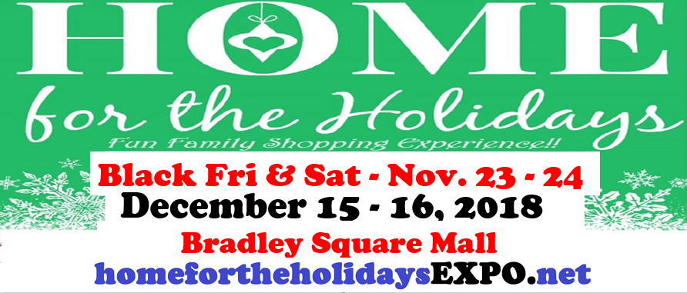
- 1,000 large flyers distributed all throughout NW Georgia & Chattanooga
- 5,000 mini Flyers placed in area hotels, restaurants and businesses
- Print advertisements in the Dalton Daily Citizen, Walker County Messenger Catoosa County, Chattanooga Times Free Press, and others
- Websites including the official festival website:
- www.targetmarketingmedia.com , visitdaltongerogia.com, daltonevents.com, chattanooganow.com, eventsnearhere, J103, festivalsandfairs.com, Eventbrite.com, Facebook groups, local FB yardsale online.
- Social media including official festival Facebook page, Twitter and Instagram
- Yard Signage throughout NW Ga and Chattanooga
- Flyers a
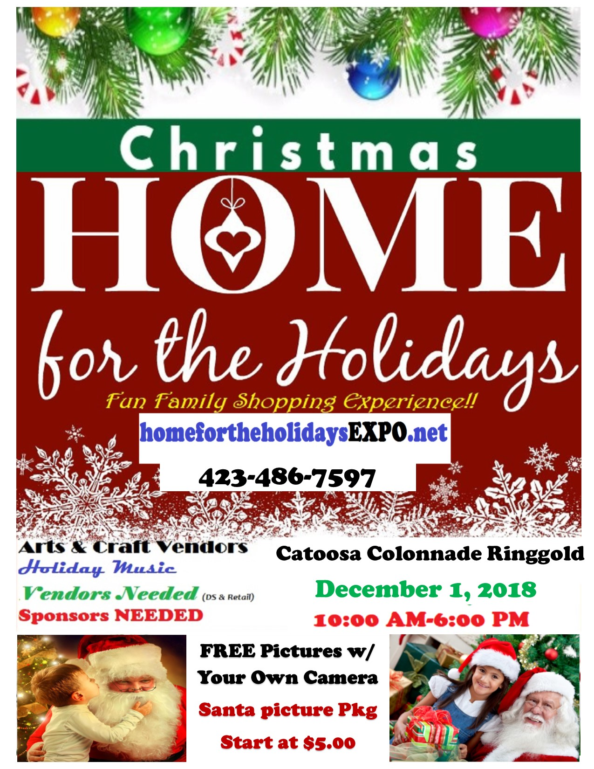
- Official news releases
- Banners erected in community locations
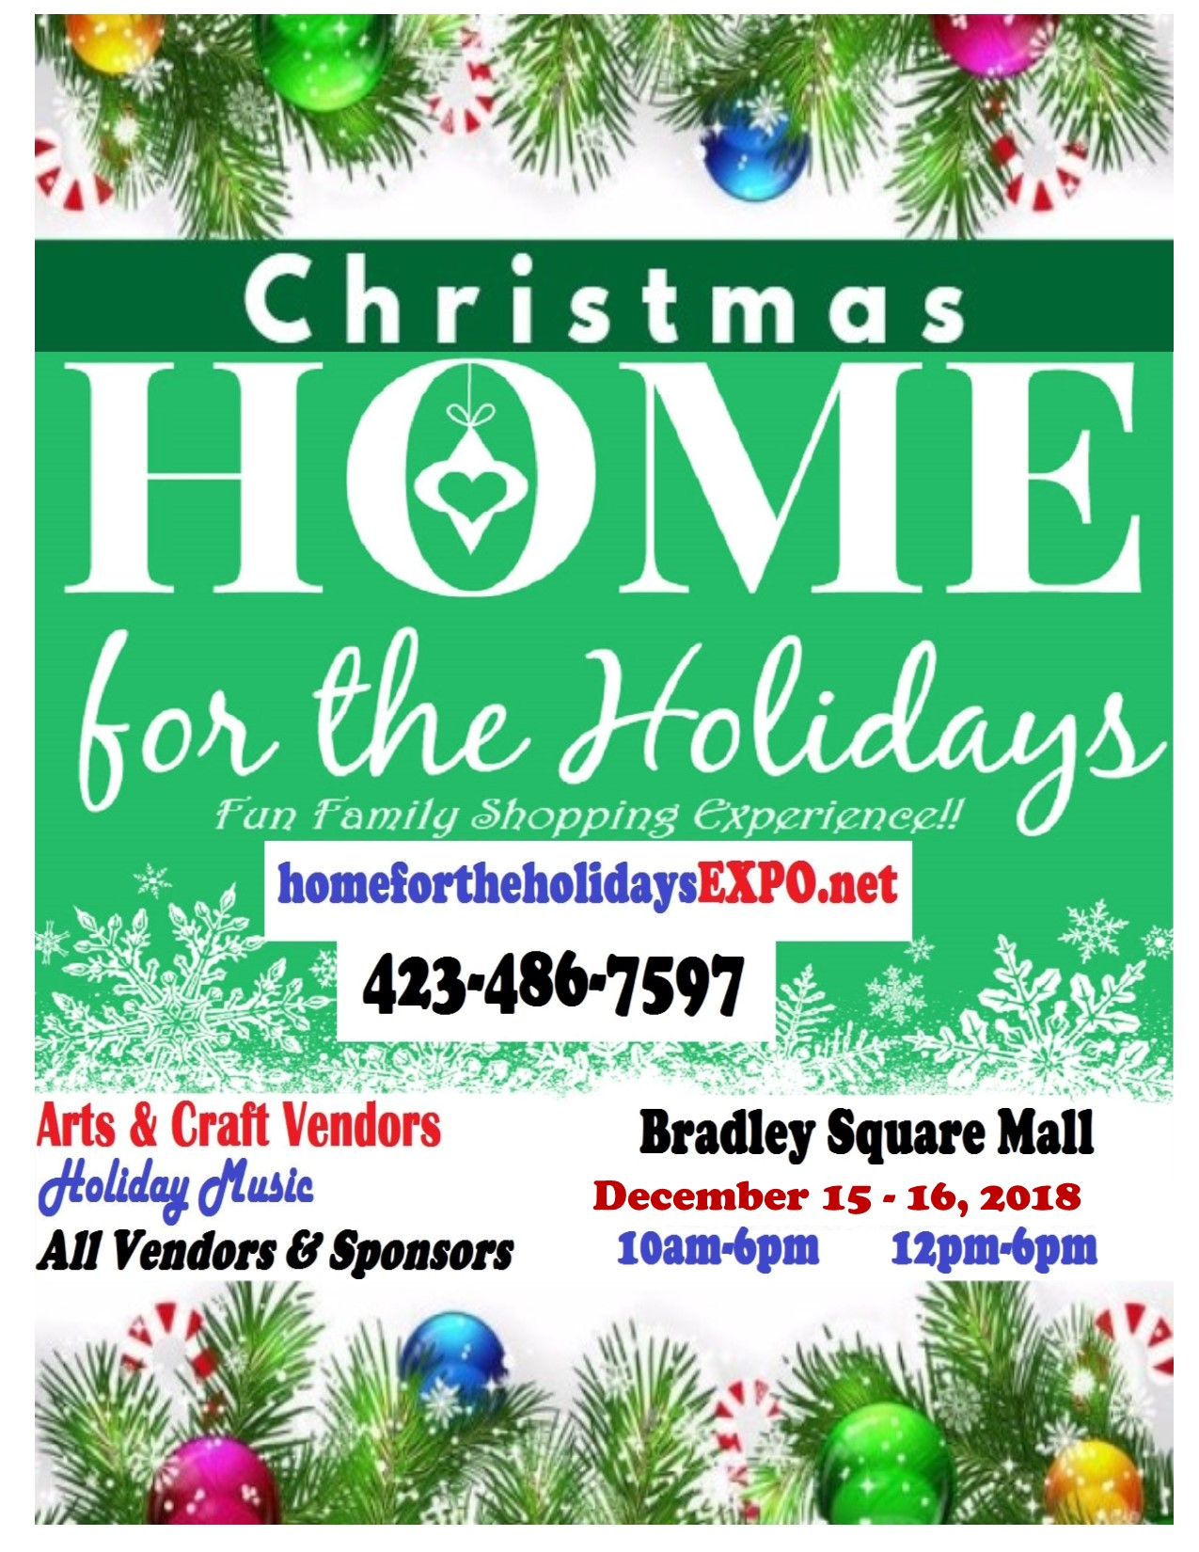
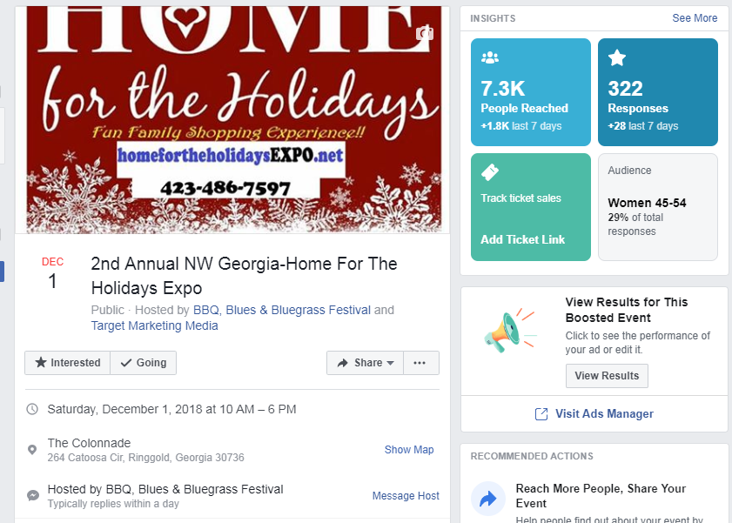
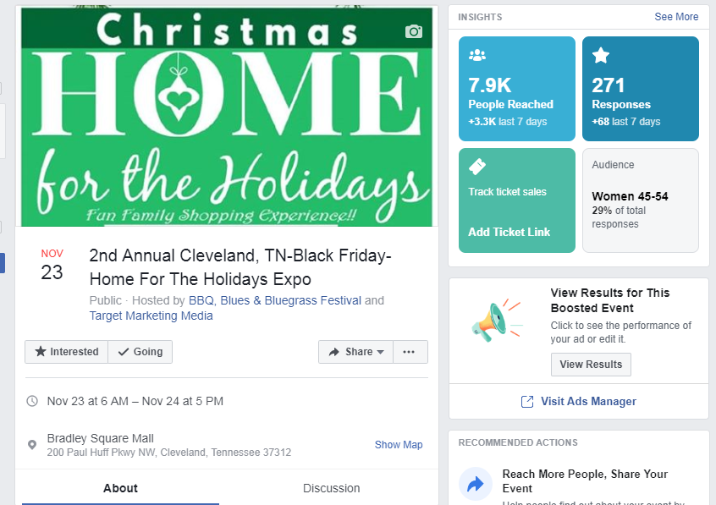

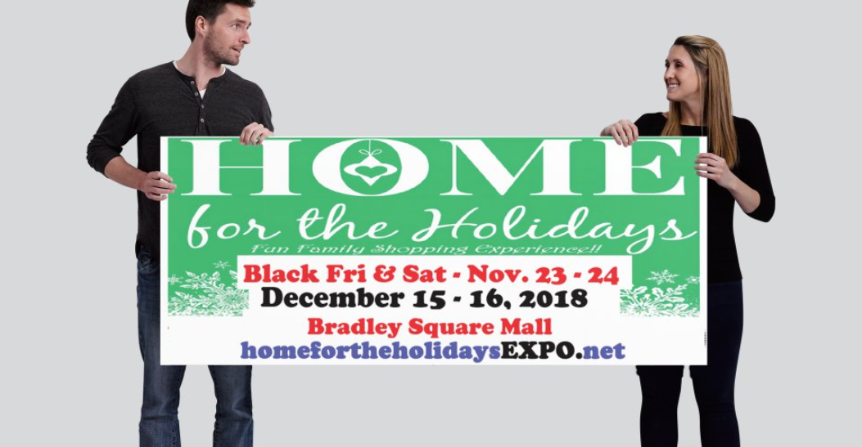

Craft fairs can be your best friend or your worst enemy. Before you spend all the time and money applying for fairs, buying booths, and making product, read through these guidelines from our contributor Vicki O’Dell. She’s pulled together the top things you need to know before heading out to sell at your next craft fair.
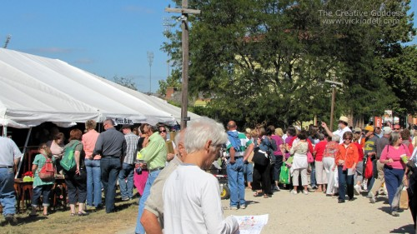
1) Read through all information sent to you regarding the show making note of set-up times and procedures. Make sure you understand all requirements and obligations regarding the show. File all related paperwork so that you can refer to it again just before the craft show. Getting in touch with the show coordinators right before the show is hard to do as they are working very hard to set up the show and extremely inconvenient for them. If you do have legitimate questions make sure to make a list of them so that you only call once.
2) Always stay open until the very end of the show. Packing your booth early sends the message to customers that the show is over and shopping is done. It also irritates your fellow craft show vendors. Just because you think you may not make a last minute sale doesn’t mean they won’t. I can’t count the number of sales I’ve had at the 11th hour because someone saw something in my booth earlier in the day and had to have my doodad before they left the show. As tired as you are and as anxious as you may be to be on your way… wait.
3) Keep a positive attitude at all times. Settle any disagreements, whether with the show organizers, a customer or your spouse, away from the booth. Be positive with your fellow vendors (even if you aren’t a big fan of them or what they are selling) and customers. A positive attitude sets the tone in your booth and surrounding areas making shopping much more pleasant. You may not be the only one selling purple doodads but you can be the NICEST person selling purple doodads.
4) Create a booth that is inviting and pleasing to the eye. Keep boxes and packaging out of view and keep your space clean and tidy – including during set up. Make sure all table coverings are laundered before the show if needed. Make sure your tent is clean and in good repair. Visit retail stores while designing your booth set-up or a visit with a friend who is an interior designer for inspiration.
5) Do some of your own marketing for the show in advance. If every vendor reached out to their friends, family, social media circles etc. it would benefit every vendor at the show. If you received flyers be sure to hand them out.
6) Stay focused on what you are doing – selling and tending to customers. Visit with family and friends in the food court, leave your children with a babysitter, eat your meals away from the booth and give your shoppers 100% of your attention. Shoppers don’t want to interrupt your conversation or your breakfast to purchase an item.
7) Be professional. Dress nicely and keep advertising, political or off color humor to a minimum on your clothing, buttons, etc. Unless it’s that kind of show. Dressing nicely lends and air of quality to the items you sell.
8) Talk to people in a general, friendly manner – no “hard sells” please. Comment on their clothing, jewelry, or the weather. Don’t sit in the back corner of your space and expect customers to hunt for you. Be present. Pay attention to the people around you.
9) Be respectful of your neighboring vendors. Keep smells to a minimum, even if you are selling candles you don’t have to light them all. One will do. If you must play music keep it quiet so that only the people in your booth with hear it. Stay within your defined space, be aware of what neighbors are selling and be willing to “spell” them if they need a bathroom break. This helps everyone sales and crates goodwill among fellow creatives.
10) Network. Use set up time, the time before the show opens or just after the show closes to network with fellow crafters. You might learn of another show you didn’t know about before, find a better hotel rate, or find out where the best bathrooms are. Hand out business cards or flyers to anyone interested. After the show, send out emails, visit blogs and leave comments and promote artists or crafters that you connected with in your social media circles.
Not all craft shows are rainbows and unicorns. Eventually you will have a show that, for one reason or 10 reasons, just doesn’t go well. It will pay to keep these 10 Commandments in mind no matter what happens.
You just never know… If you are doing several local shows people will remember you and recognize you from show to show. Play your cards well, create products your customers love and treat them well and it won’t be long before they will be searching for your business name on the vendor list.
You just never know… If you travel to shows you are likely part of a group of vendors who see one another from event to event. Being kind, going out of your way to be helpful and having a positive attitude makes life easier for everyone.
You just never know… where a new client, customer or friend might come from.
By: Vicki O’Dell , The Creative Goddess

Improve Your Booth Etiquette to Increase Sales at Craft Shows

As with any retail business, craft shows require a certain level of etiquette to ensure you are bringing in as many sales as you can. It isn’t enough to be talented; you also need to be aware of the other aspects of this industry that can result in higher profits. They say you catch more bees with honey than vinegar, and the same rings true in the world of craft shows.
The most important aspect of booth etiquette for arts and craft shows is to be nice. These shows can be long and stressful, and depending on the weather, they can also be incredibly miserable. However, you can’t let this show to your customers. Always keep a smile on your face and be prepared to grit your teeth when someone asks you the same question for the millionth time that day. By having a positive attitude during the entire process of a customer’s transaction, they will be more likely to return, maybe even with friends. It isn’t just the customers you need to be nice to either. The vendors surrounding your booth will be your neighbors for several hours so you might want to stay on their good side. Even if you aren’t the biggest fan of them as a person or what they are selling, being pleasant to them will keep the day going smoothly and keep an air of positivity around you and your booth.
You should also be prepared to stay open until the end of the show or festival. If you start packing up your wares early, your customers may feel like it’s time to go home. Those customers are the reason you are putting money in your pocket, so you want to provide them with as much of an opportunity to buy your products as possible. Fellow vendors are also likely to be bothered by an early takedown since it may drive customers away thinking the show is over.
Above all, be professional. This may be a hobby for some, but a job for others. Don’t treat the area as your own personal trash can and pick up after yourself when you make a mess. That should be a given since we are all adults here. If you consider your booth to be your place of business, act like it. You want your customers to feel confident when making a purchase from you. If you’re friendly, professional, and ready to stay open past the time of closing, you will definitely see a marked improvement in your booth sales.
Crafters' Etiquette

by Karen Booy
as published in CRAFTLINK Newsletter
Ever wondered if you knew all the "unwritten rules" of being a craft exhibitor?
The idea for this article came from show promoter Eva Hansen of The Happening, held at Thomas Haney Secondary in maple ridge, BC. Eva runs this successful craft show as part of the school program. Students are involved with organizing, promoting and running the show - right down to being parking lot attendants for the busy event! The craft show becomes a school event and its popularity translates into great sales for its craft exhibitors.
After contacting several show promoters, the feedback started to roll in on the fax machine and over the e-mail - I must admit that I was a little surprised when I read the top tips for craft show etiquette. Most of the tips I thought were, well kind of obvious, however when all the tips where in I noticed that not only were the tips simple and rather obvious - they were repeated by several show promoters! This got me to thinking that the simple manners that so many of us take for granted are not so obvious to many! So I hope that you will read over the tips of do's and don'ts and perhaps it just might be an eye-opener for you as well!
The Happening Crafters "Do" List - Eva Hansen
- DO read all the information you are sent regarding times, set-up procedures, policies and be prepared to abide by them. Then file the information so that you can refer to it just prior to the craft fair. If you do this, you won't have to phone the week before the craft fair when organizers are so busy they are often difficult to reach.
- DO be on time for jurying and set-up for the craft fair.
- DO stay open until the advertised times. Packing up early sends a negative message to customers that shopping is over for the day and they should stop shopping and leave the craft fair.
- DO demonstrate a positive attitude at all times. this is in consideration of people around you. Customers respond to the tone in the room - a pleasant atmosphere increases everyone's sales.
- DO be clear about the space and facilities you have paid for and respect the parameters of your rental space. Organizers must be concerned with fire regulations, safety and traffic flow in the building. Official inspections by the Fire Marshals are common at popular public events.
- DO focus on the task at hand. If you have friends or relatives dropping by to visit with you, take a break and socialize in the "coffee" area instead of behind your table. Food should be eaten elsewhere or as discreetly as possible. Customers might feel they are intruding on your personal time if they need your attention, it is also very distracting for neighboring crafters who are trying to conduct business.
- DO make use of childcare facilities (if available) or make alternate arrangements.
- DO present a professional appearance. Dress professionally and be well groomed. Be mindful that members of the public may take offense to clothing with certain advertising or questionable humor.
- DO make your craft space an inviting environment. Standing up, making eye contact, smiling and greeting customers in a friendly manner goes a long way towards increasing your sales.
- DO keep your display and workspace clean and tidy. Storage boxes and garbage should be well out of sight.
- DO make yourself aware of other products available at the fair so that you can refer customers who are looking for a product you don't carry. This helps everyone's sales and creates goodwill.
- DO make a special effort to distribute as many flyers and posters that you can increase in numbers mean increased sales!
- DO thank organizers if you’re pleased with the fair. If you feel there were problems, offer suggestions to the organizers for improvements. Also be sensitive to their point of view if they don't agree with you. Sometimes changes cannot be made because of conditions beyond their control.
- DO resolve conflicts with craft fair organizers or others away from the sales floor. Customers and other crafters are uncomfortable when tension is evident and everyone's sales suffer.
- DO learn from the jurying process. Remember that the objective of the jurying process is to ensure that a good selection of saleable and compatible products that are fairly priced will be available for the show. Overall selection will vary from year to year, as may the jury panel. If you weren't selected on year, do apply again the next year.
********
Colleen MacKinnon, of Rag-a-Muffin Collectibles Inc., has been selling her dolls, Santas and ornaments at local craft shows and gift shops since 1990. In addition, Colleen promotes 'Twas the Month Before Christmas.' This year will mark the fourth anniversary of what she calls "our show" or 'Twas' for short. It is a blended display of antiques, crafts and food items. The show runs at Tynhead Community Hall, Surrey BC. Colleen hopes to have a website up and running later this year.
Tips for a Blended Craft Show - Colleen MacKinnon
- Be willing and prepared to work as much as possible
- Do bring a display that fits the size allotted.
- do smile and interact with customers in a casual & friendly, yet business - like manner.
- Keep jokes and casual conversations with other vendors to a minimum.
- Pay attention to customers' needs. wants. Upselling should be kept to a minimum.
- Deep an accurate inventory list.
- Have an item to donate for gift basket/door prize.
- Have all items clearly marked with price.
- Bring lots of business cards.
- "Fluffing" and tidying of displays is important. Keep dolls and ornaments facing the customer.
- Never criticize or demean another vendor's product or personality.
- Make a point of getting to know the other vendors and their products. does it complement yours? You never know where a new client or friend might come from.
- Don't openly solicit vendors for "you" craft show. There is a time and place for everything.
- Learn how to use a cash register.
- Don't bring a product that was not juried.
- Remember, be willing to "go with the flow" ... the show and season are short!
*********
Barb St. Laurent is the organizer of another blended show in Cloverdale BC. Here are Barb's suggestions for maximizing your time and effort at a home show.
How to Maximize your Time & Effort - Barb St. Laurent
- Dress up. Let your customers know they are buying quality crafts from classy people.
- If you have a problem go directly to the source - don't undermine the show by grumbling to each other.
- Teamwork - build each other up.
- Hand out flyers - they are costly so don't waste them by not distributing them, only to have to throw them out after the show.
- Come to the show happy. A smile is very contagious.
- Treat every single customer with courtesy and respect. Without them there would be no show!
- Please understand that the promoter of the show is under a great deal of stress during the craft show. She is working on your behalf so help where you can.
- Have fun!
********
The following tips come from the promoter of one of Western Canada's most successful craft shows. The Coquitlam Craft sale just celebrated its 22nd year for the Christmas Sale and its 11th year for the Fall Sale. Show organizer Becky McDonald is now doing the show with her daughter! Since Becky always has more crafters than booths, she can afford to be selective when choosing exhibitors. What does becky recommend when it comes to craft show etiquette?
Craft Show Etiquette - Becky McDonald
- Respect - Respect other crafters around you - don't plan your display so large that it infringes on the people on either side. Don't cover the entire floor area with boxes during set up.
- Respect the organizers. If there is a problem, discuss it with the show organizer (who can do something about it), not the people on either side of your display.
- Product Line - Check with the organizers before adding any new crafts to your display. The crafters have been well placed and anything new may be the same as someone next to you.
- Promotion - Do what's asked of you regarding the advertising and let the organizers know what you've done.
- Presentation - Dress well. No jeans. The more effort you make to look good, the better your sales will be. if you don't make the effort to look good the customers will think your craft was thrown together as well.
- Display - Use the space you paid for. Rarely will a sale allow electrical cords running across the floor, so if you need to use electricity make sure you pay for and request a wall space.
- Don't change your display at the last minute and expect the organizers to remove a table from your spot on the day of the sale. It interferes with the other crafts people setting up their displays.
- Only use the space you paid for. The table have been carefully laid out to pre-show requirements. If you see extra footage not being used, it may be that the person who has paid for it has not yet arrived.
- Paperwork - Check to make sure your cheque has been cashed so you know you're registered. One year, we had three people show up for their tables who we did not have registered. It was embarrassing at the time thinking we were to blame and then the next week they sent cheques in with an apology.
- Harassment - Don't phone the organizers repeatedly with questions. Save them all up and make one call. Better yet - read your show material - chances are the answers are there! The organizers are dealing with a lot of other crafters and if they all called three or four times, it amounts to a lot of time on the phone! Wouldn't you rather have your show organizer spending her time promoting the show to improve your sales????
- Complaints - Don't complain out loud how the sale would be better if only the weather were better, or in some cases, worse. Customers overhear these remarks and get a negative spin on the sale.
- Bridges - Don't burn your bridges with the organizers. Even if you haven't done well at that particular sale, always seek out the organizers and say thank you. Believe me, it's remembered and may make a difference the following year when the tables are being allocated.
- Preparation - Make a checklist of things you'll need to take to the sale. Sometimes the obvious things like a float, extension cord, power bar or table covering get overlooked and the organizers may not have an emergency supply to cover your forgotten items.
********
Keeping It Positive - Trudy Ferguson an Judy Meixner
- Be customer friendly, focus on selling, talk to people, and stand up.
- Be positive and encouraging - even when you aren't doing as well as you would like.
- Smile be enthusiastic, and approachable. Consider the needs of the other people around you.
- Bring any problems to the promoters first, don't spread problems, it creates a negative atmosphere that no one needs.
********
Our tips from eastern Canada come from show promoter Leslie Bailey of Celebration Exposition of the Arts, her show runs in Thunder Bay, Ontario. Leslie Bailey works in wood and fabric to design whimsical/folkart country collectables.

Tips for Eastern Canada - Leslie Bailey
- Display-Display-Display - I can't stress enough the importance of display. It gives a show a professional look when all artisans have creative displays. It keeps the customers coming back year after year, and most important it improves your sales. Nothing looks more like a flea market as when crafters lay everything on a table in front of them. I would almost go as far as banning tables all together except some people do use a table creatively.
- Be courteous of your booth neighbors. Stay within your space.
- Dress - Dress professionally! You are representing your work - if you were selling at a department store you would have a dress code. Here you are selling your work, show some pride and dress accordingly (never old jeans or sweats).
- If possible man our own booth at all times. People like to talk with the artist. No one knows your work like you do. If you are unable, be sure the person you have is knowledgeable about your work.
- Set Up and Tear Down - Be sure to be set up on time. Nothing is more unprofessional than opening the doors to the public and you are still unpacking stock or rearranging displays. when the doors open you should be ready at your booth with a smile to greet your customer.
- Never start to dismantle your display before closing. If the show is over at 5pm, then at 5:01 is when you should start tearing down. Although it is often slow during the last hour of a show, there are still customers who might hurry out without buying if they think you just want to get out of there. Even if you don't have a sale your neighbor might - so be respectful of that.
- Paperwork - Submit all forms, contracts and payments to show management on time. Organizing a quality show is a lot of work and when we have to waste hours calling exhibitors for paperwork of payments - we could be lining up more promotions etc. it is very frustrating.
The following tips come from show promoter, Paul Yard of the prestigious Circle craft show held at the Vancouver Trade and Convention Centre in Vancouver BC.
A Promoter's Pointers - Paul Yard
- Stay out of other people's booths if you don't have an invitation... particularly booths with similar products to your own.
- Wear your identification even if most of the staff know you. Keep your booth open and looking sharp at the hours that the show is open. Don't start packing up an hour before closing!
- Follow up promptly with orders and commitments that you make at a show. failure to do so not only reflects on you but on the show as well.
- Be neatly dressed and clean! wear deodorant - comb your hair!
- Try and have relief for lunch and coffee breaks if at all possible. don't eat in your booth....and certainly do not drink (alcohol).
I am sure that you found these tips to be extremely enlightening. You will now be off to the shows on your best behavior! Have a great show season.

